**Assignment 1**

1.Write a Java program to print the product of two numbers.

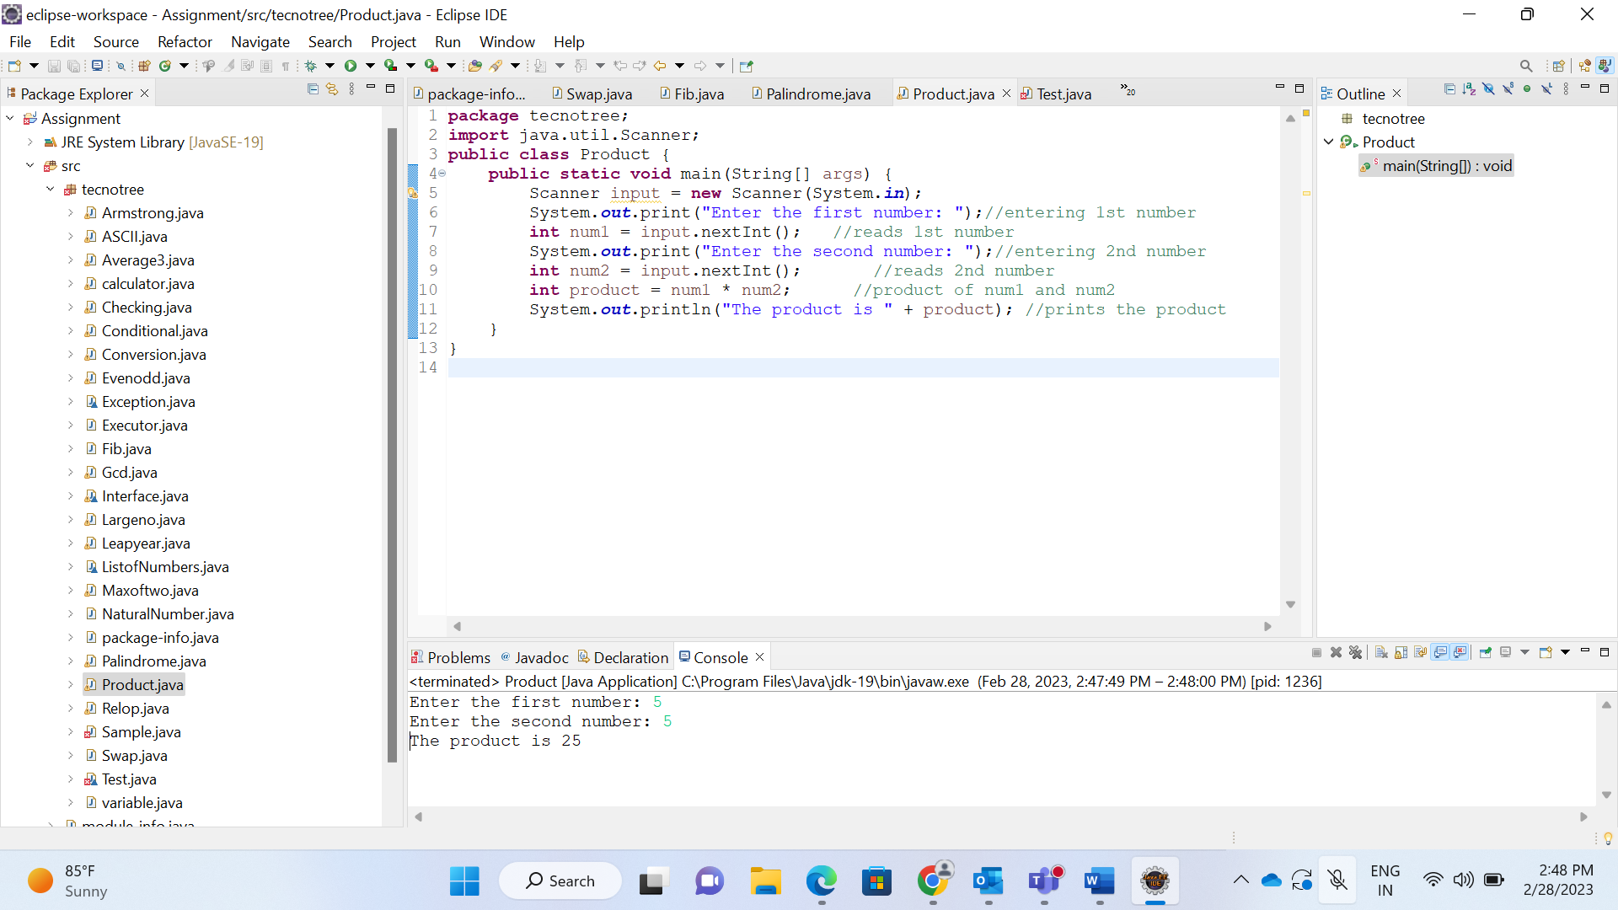 <https://codeshare.io/LwEbDp>

2.Write a Java program to calculate the average of three numbers.

<https://codeshare.io/X8Edeo>

3.Write a Java program to check whether a given number is even or odd.

<https://codeshare.io/JbM8qK>

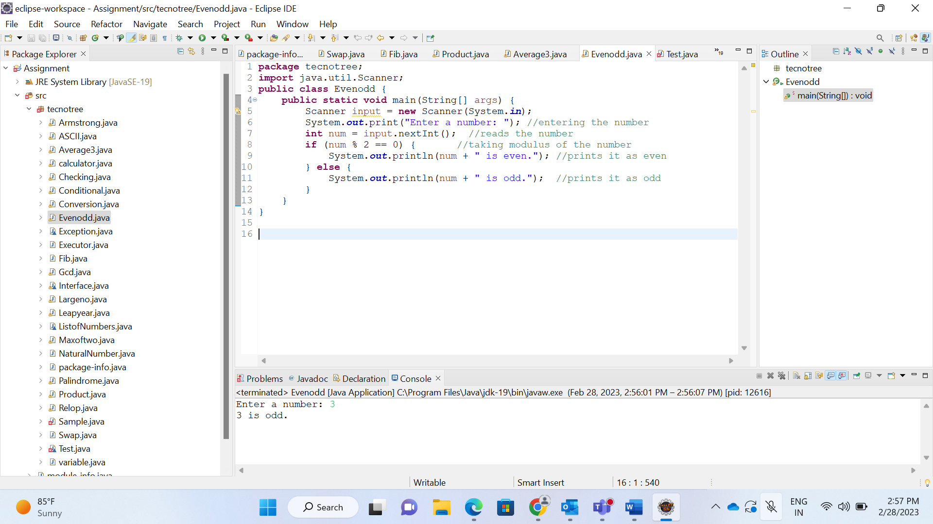

4.Write a Java program to check whether a given year is a leap year.

<https://codeshare.io/ZJEnMQ>

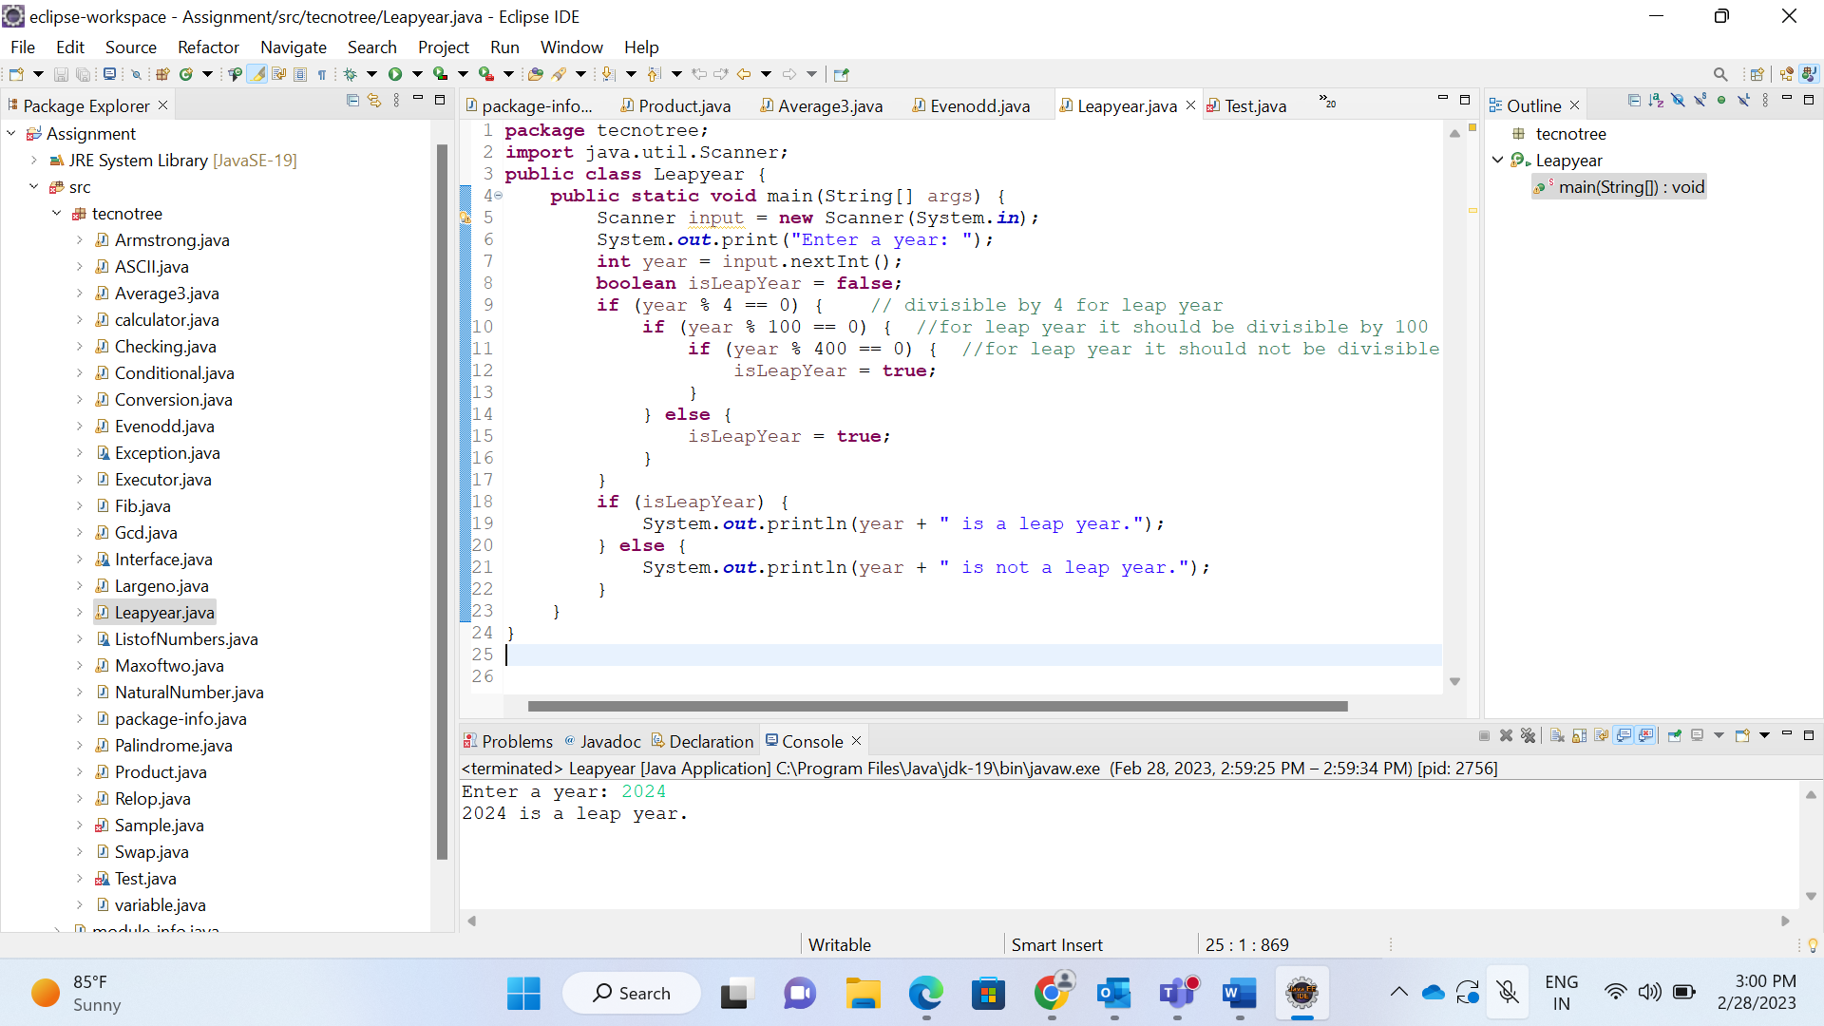

5. Write a Java program to print the ASCII value of a given character.

<https://codeshare.io/nzolR1>

6. Write a Java program to convert Celsius to Fahrenheit.

<https://codeshare.io/6pkweO>

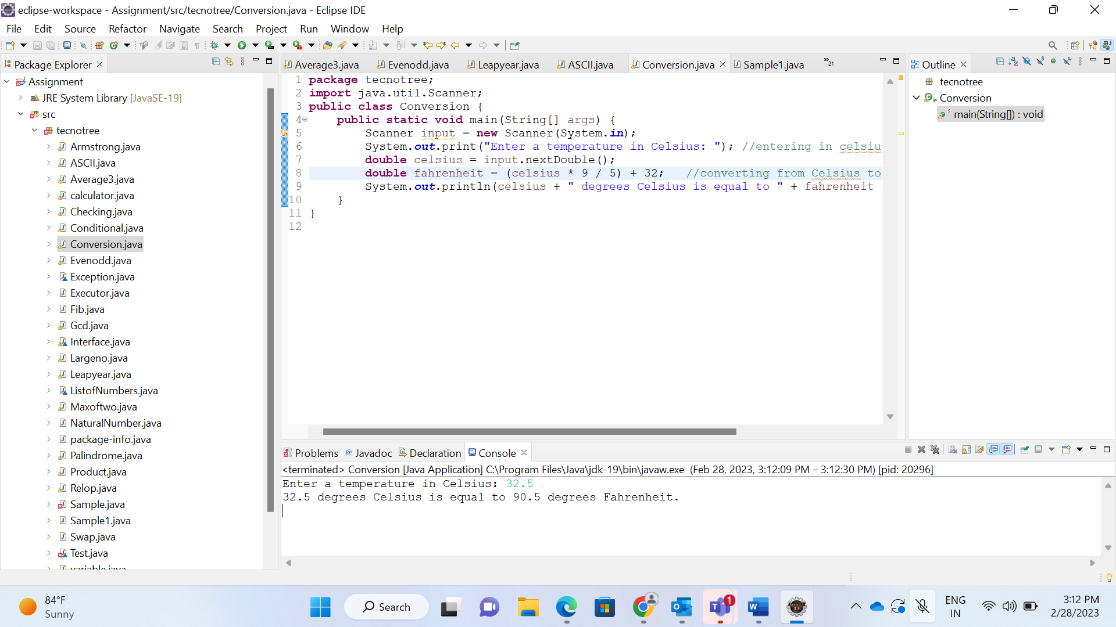

7. Write a Java program to find the maximum of two numbers.

